Quantitative Analysis of the Variables That Determine the Period of a Pendulum

By David Jefts, Alden Arien Amulyoto, Tsion Eshetu

PS253 Physics Laboratory for Engineers

Section 08, Dona Kuruppuaratchi & Dylan Labbe

Department of Physical Sciences

Embry-Riddle Aeronautical University, Daytona Beach, Florida

22nd of September 2018

**Abstract**

The goal of this experiment was to quantitatively measure the variables that affect the period of a pendulum in motion. The question this experiment tried to answer was: “What influences the period of a pendulum?” This experiment involved changing every variable possible and graphing, and analyzing, the data in order to determine what variables had the greatest effect on the period of swing. The variables that we controlled were length of the pendulum, arc length of the pendulum’s swing or the initial angle of release, and mass of the weight on the pendulum. We assumed that the string from which the pendulum mass was hung had no mass. Based on our results, the period of a pendulum swing is not at all dependent on the initial angle of release or the mass and is only dependent on the length of the string.

**Background**

Galileo Galilei performed this same experiment beginning in 1602 [3]. He had a similar question in mind, but his goal was to try to make pendulum clocks more accurate around the world. In his experiment, he discovered that pendulums have the property of isochronism; the period of a pendulum is independent of the amplitude of the swing, or the length of its arc. His discoveries are what allowed the pendulum clock to exist, and to have accuracies of ±15 seconds per day. Our pendulum was not able to measure time nor was it accurate by any means. We tested every possible variable and were also able to determine the local acceleration due to gravity constant using Newton’s Laws. We did not deviate from the lab procedure in any way however, our results may have been more accurate with more trials.

**Theory & Methods**

A single-string pendulum has the opportunity to swing in two dimensions, which would cause the pendulum’s swing arc to be circular. For this experiment, the ideal arc was a curved line in one plane. To accomplish this, we attached one long string to a crossbar at both ends.

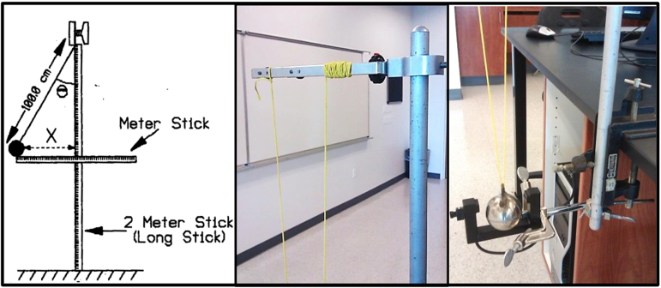

*Figure 1: Setup for simple pendulum test. (left)Illustration of basic setup. (middle) Image of top crossbar setup. (right) Image of photogate setup and pendulum bob attachment for spherical mass. [2]*

The mass was hung from the middle of the string and the length was measured in a straight vertical line from the pendulum mass to the crossbar. Figure one is an accurate depiction of this, with the top half of the pendulum system shown in the middle image. The right image shows the bottom half of the pendulum and how the pendulum mass was hung between the ends of the string. The left image is a sideview of the experiment setup, “Meter Stick” was used to measure the horizontal distance the mass would be released from and was calculated using equation 1. X is the horizontal distance as shown in Figure 1 (left) and L is the length if the pendulum.

(0)

(1)

“2 Meter Stick (Long Stick)” was just used to hold the pendulum system up off of the ground.

Each trial of the experiment involved drawing back the pendulum X distance, and then releasing it in such a fashion that it swung through a photogate that recorded the length in seconds of each period. One period is the amount of time required for the pendulum to return to its position of release. We performed a total of thirteen trials. The first five trials used an L of 1meter and a mass of 0.983±.05kilograms, these trials tested whether the initial release angle affected the period. We based each trial off of the angle of release, using 5° increments starting at 5°. We used Equation 1 to determine what the equivalent horizontal distance would be. Trials six through eleven changed the length of the pendulum from the center of mass of the pendulum bob to the cross bar. Each of these trials released the pendulum from 5° and continued to use the same mass as in the first five trials. We did not have much room to extend the length of the pendulum, so we opted to decrease the length of the pendulum in each trial by 10centimeters per trial. Trials twelve and thirteen used the original pendulum length of 1meter and continued to use the 5° release angle. Trial twelve used a mass of 0.4966±.05kilograms while trial thirteen used a mass of 0.1891±.05kilograms. All of our data was recorded, compiled, and graphed by Microsoft Excel.

**Results**

For our first five trials the average period was 2.028s with a standard deviation of 0.002s. This graph is shown in figure

*Figure 2: Graph based on data from the first table in Plot Data. This graph displays the data from columns 4/5 (Horizontal Displacement in meters is based off the angle of release) and column 6 (Period in seconds). This graph represents trials 1-5.*

These trials show that the initial angle of release barely affects the period because there is no significant change between trials and the deviation from the mean is extremely small. As depicted in the graph, the slope of this line is nearly zero.

For the next six trials the period was not constant and had a linear relationship with the length. The difference between Figure 3 and Figure 1 is very significant and represents that the Period is dependent on the Pendulum Length. Figure 3 has a slope ≠ 0 therefore the Period is based on the Pendulum Length.

*Figure 3: Graph based on data from the first table in Plot Data. This graph displays the natural logarithm of the data from columns 2 (Length of the pendulum) and column 6 (Period in seconds). This graph represents trials 1 and 6-11 after the natural logarithm of each data point was taken.*

In our experiment, we have Equation 2 which defines an exponential relationship [2].

(2)

(3)

(4)

In our experiment, we had Equation 2 which defines an exponential relationship. Figure 3 provided a line of best fit for the data. The values for *n* and *K* in Equation were derived from the line of best fit. Based on this *n*=0.4875 and ln(*K*)=0.6964.

*n=0.487* and *K=2.007*

Those values were substituted into Equation 2 to provide an equation to estimate the period of a pendulum (5).

**(5)**

To determine our percent difference (6), we compared Equation 7 to our *K* value, and our *n* value to .

(6)

(7)

*L* is still the length of the pendulum and *g* is the acceleration due to gravity, 9.79265 in Daytona Beach [2]. Our percent difference between Equation 7 and *K* when *L=1* was 0.005%. Our percent difference between *n* and was 2.53%.

There were many possible causes for a discrepancy for *K* and for *n*. We did not account for air resistance in the pendulum’s swing which is a source of Systematic Measurement Uncertainty. This could have been eliminated if we were able to perform this experiment in a vacuum or if we possessed the knowledge to calculate air resistance for our pendulum system. Another large source of error was Random Measurement Uncertainty. When pulling back the pendulum mass we failed to accurately create an initial angle of 5°, 10°, or any of the angle measurements we recorded releasing from. Additionally, the string that the pendulum was hung from had physical substance and mass that we assumed to be zero in our calculations and experiment procedures. This would cause a source of Systematic Intrinsic Uncertainty.

**References**

[1] Jefts, David. “Raw Data.” ERAU, Daytona Beach, FL, 5 Sept. 2018

[2] Schumacher, Donald. “Pendulum Tests – Discovering What Variables Affect a Pendulum’s Period” ERAU, Daytona Beach, FL, 24 Oct. 2016. Reading.

[3] Galilei, G. (1929). “The works of Galileo Galilei in the original text. Prospectus of the reprint of the national edition. (Le opere di Galileo Galilei. Ristampa della edizione nazionale.)”. Florence: G. Barbèra.

**Plot Data**

